Customer: 12th Auto engine at+35C
Job#: Random vib

Data: C:\Users\ESSII\Desktop\Auto engine\2022May22-2253-0014.vrd
Test: C:\Users\ESSII\Desktop\auto engine .5g.vrp
Data stored on May 22, 2022 23:01:01
- -
Running

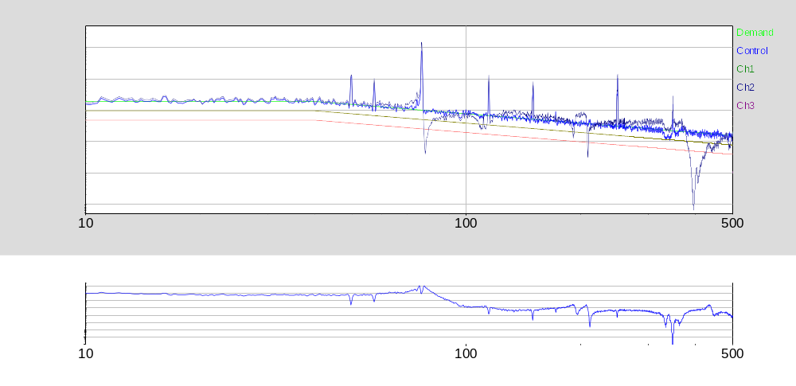

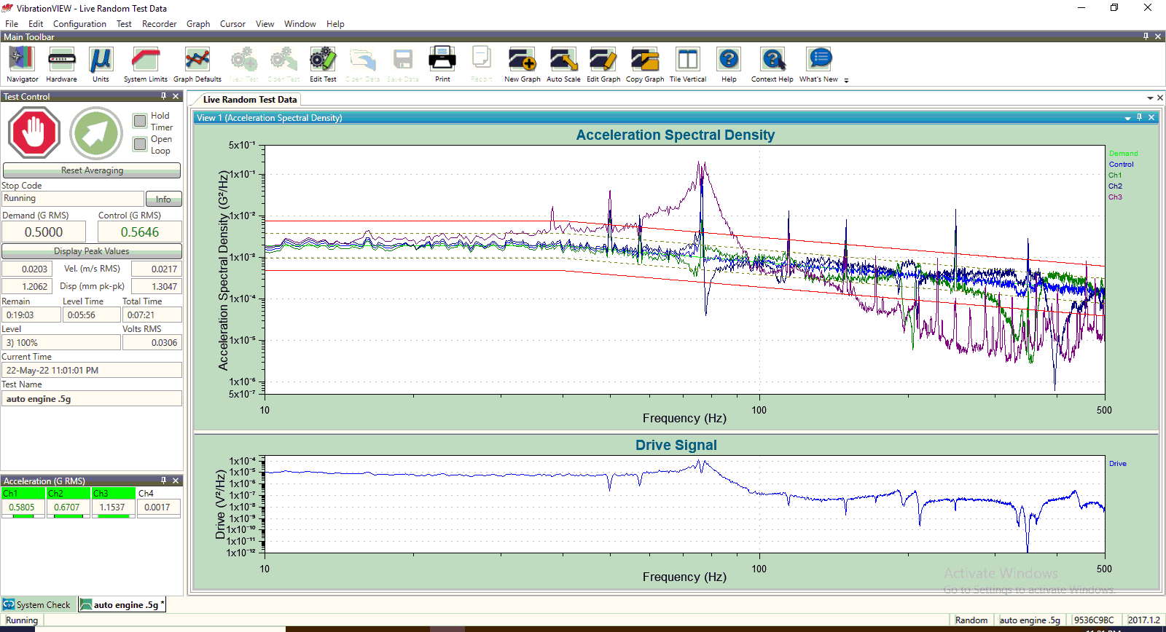

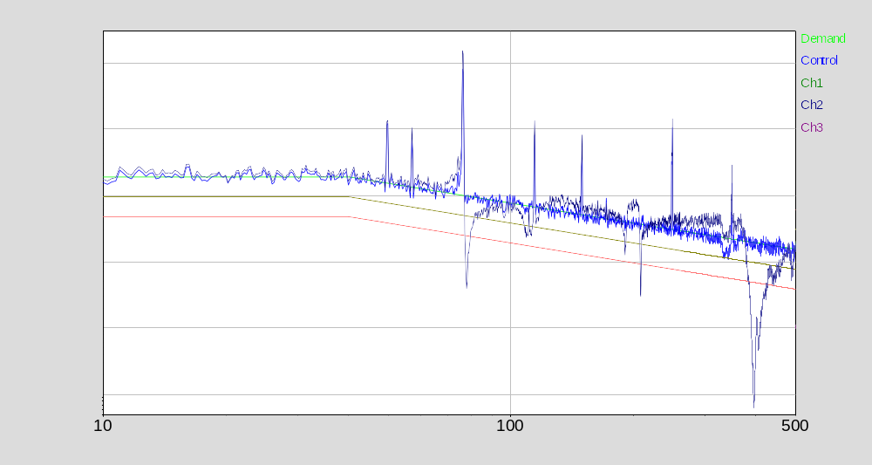

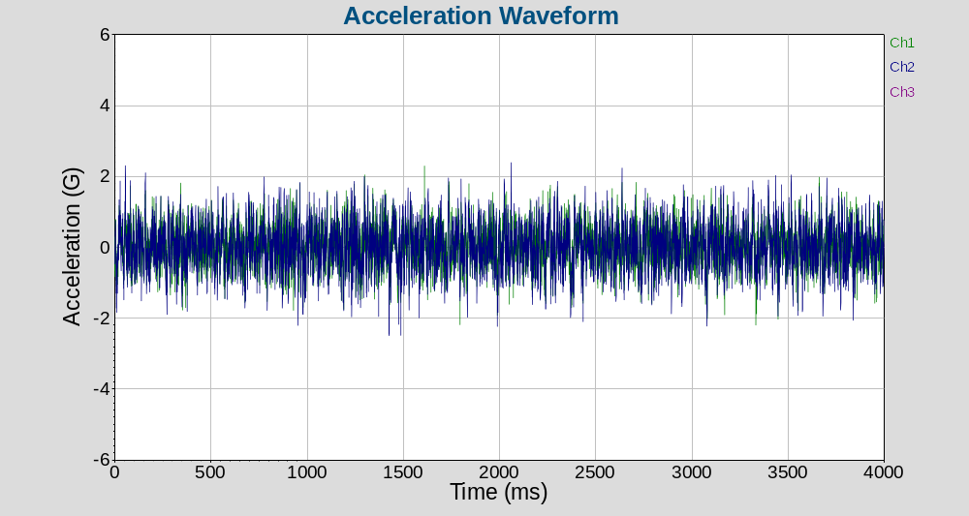

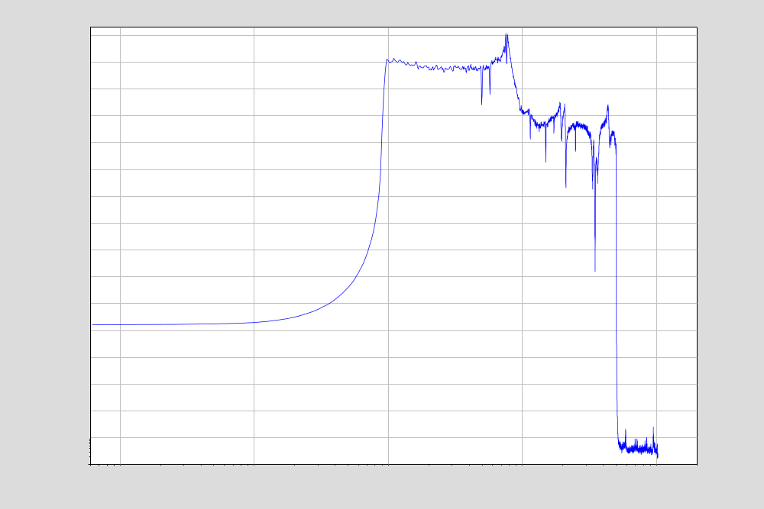

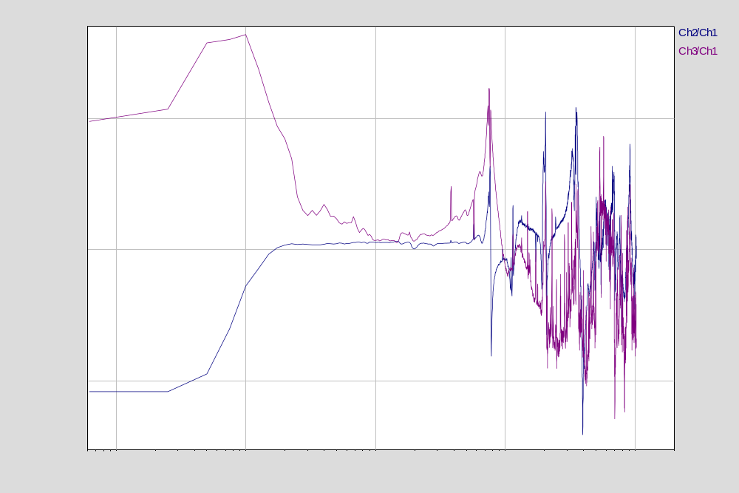

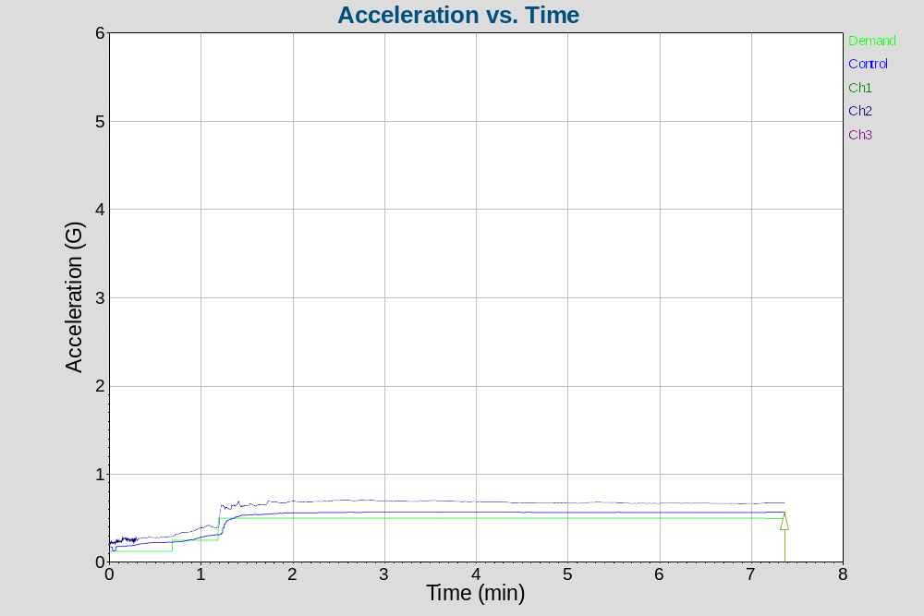

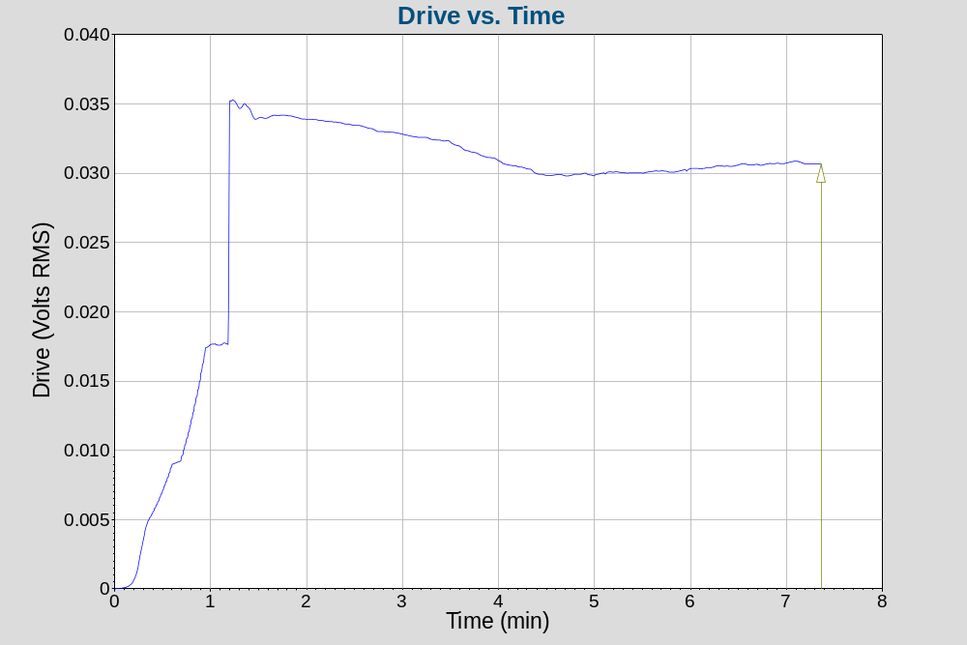

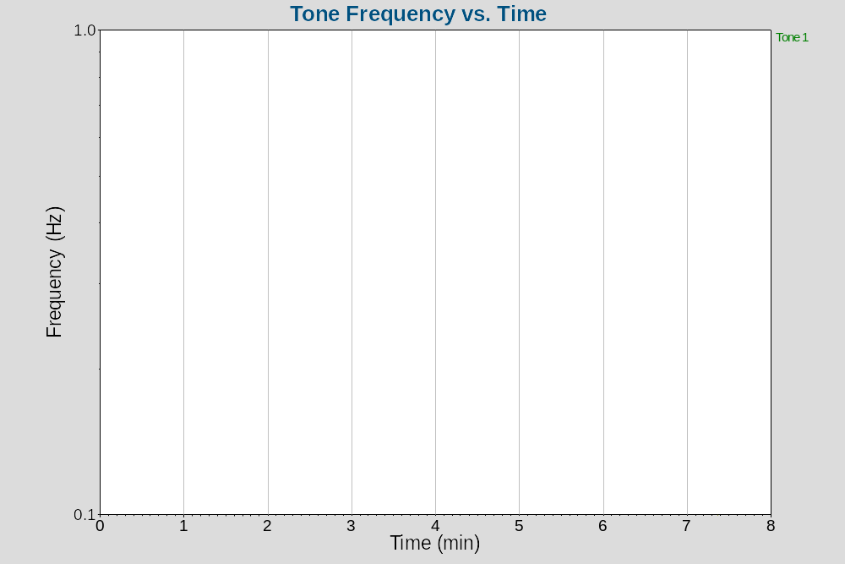

Breakpoint table
Frequency G²/Hz dB/Octave
10 Hz 0.0019 0
40 Hz 0.0019 -3
500 Hz 0.0001533

Test level schedule:
Duration Level
1) 0:00:05 25 %
2) 0:00:05 50 %
3) 0:25:00 100 %
** Test started May 22, 2022 22:53:39, running for 0:07:22
** Current level: 3, running at 100 % for 0:05:57 of 0:25:00

Measurements:
Demand: 0.5 G RMS 1.206 mm pk-pk
Control: 0.5646 G RMS 1.305 mm pk-pk

Channel Measurements:
(Overall) (InBand)
Ch1 0.5798 G RMS 0.4896 G RMS
Ch2 0.6695 G RMS 0.6299 G RMS
Ch3 1.154 G RMS 1.166 G RMS
Ch4 0.001681 G RMS 0.001424 G RMS

Channel Calibration:
Ch1 10.11 mV/G 110813, Mar 08, 2022
Ch2 97.2 mV/G 16662, Dec 27, 2021
Ch3 96.8 mV/G 16666, Dec 21, 2021
Ch4 10.11 mV/G 110817, Mar 08, 2022

Hardware calibration details:
Serial Date of Days since Calibration Days until
Number last cal last cal due date cal due
9536C9BC Sep 15, 2020 614 days Sep 15, 2021 Past due by 249 days

Test Notes:
Test notes: none

